* 1. **Document management**

**Summary of functionality.**

1. The documents are classified as various “Submittals” The submittals can be associated with any task/subtask or can be under the “work package”.
2. Each submittal belongs to a category (of submittals). The different categories are General, Process, Civil/Structural drawings, Technical data sheets, general drawings- planning drawings, electrical drawings, instrument drawings etc….
3. Each submittal can follow a flow (submit/ review/approve etc..). The flow defines steps , sequencing of steps and target sates for completion of these steps.
4. There will be target dates assigned to each step of the flow and for each step users are assigned who are responsible for that step in the flow.
5. The documents in “submittal” are submitted with covering letter and they are assigned a reference number. Typically each “submittal” will be a folder and documents under it.
6. Any revised submittal will have the same folder structure and all documents in the folder.

Click “Documents” in main menu (as shown below) to get document tracking information.

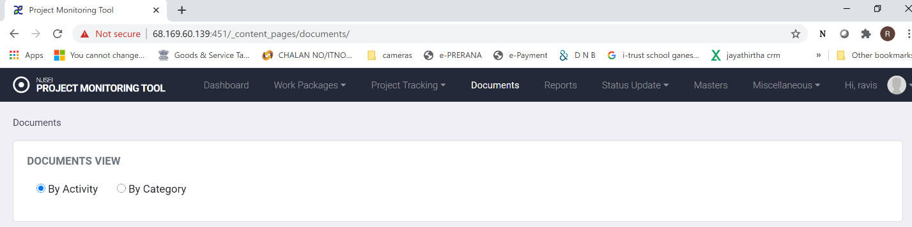

**Click “Documents” in main menu to get document tracking information.**

* 1. **View Documents:**

Click “Documents” in main menu bar. You see following options.

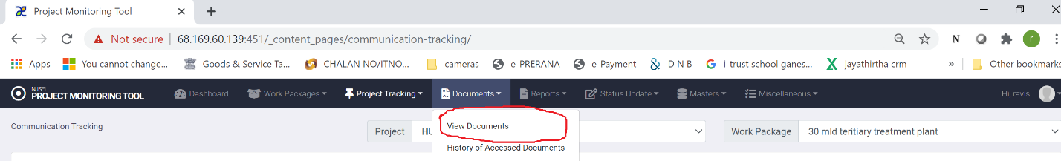

Click “View Documents” you will see following screen.

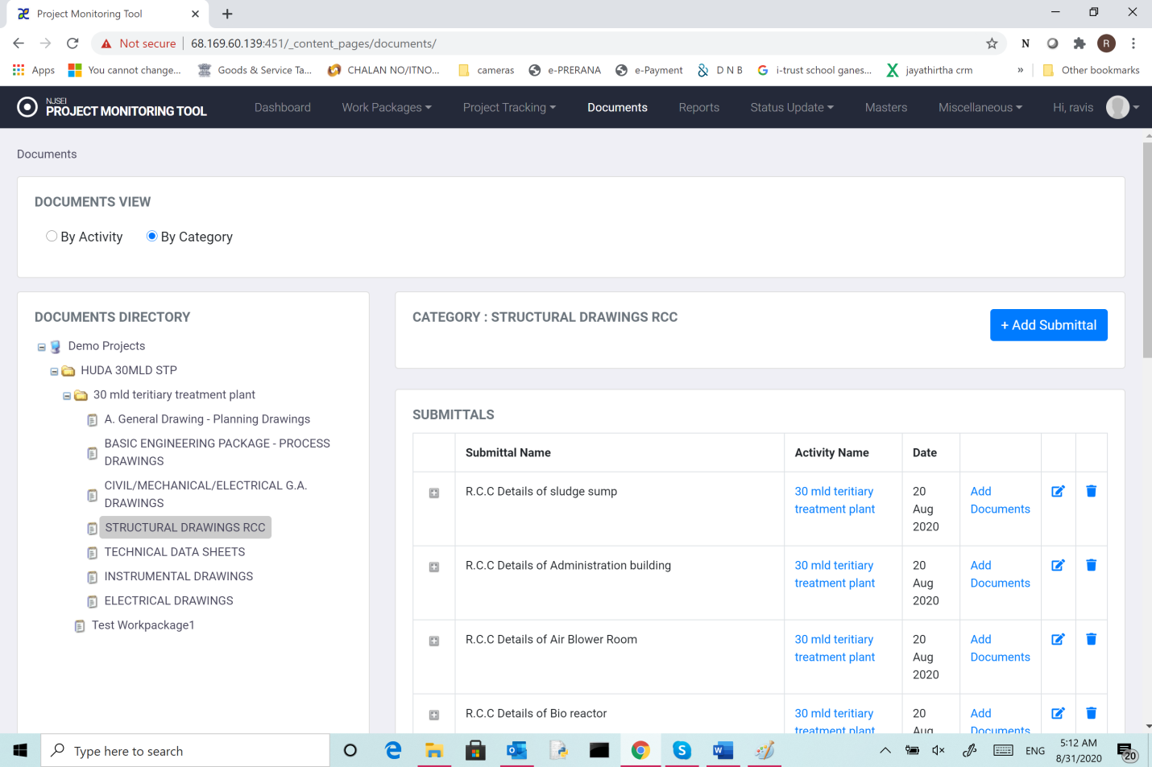

There is a option to view by “category” or by “activity”.

1. “by Category”: The documents are assigned to various categories like civil engineering documents/Structural drawings etc.
2. or “by Activity”: The documents can be associated with an activity.
   * 1. **View Documents by “category”:**

If you click “by category “, You will see list of categories in the tree.

Choose any category whose documents you want to view. You will see following screen.



1. For each submittal
2. Name of the Submittal,
3. Activity name (if submittal is associated with an activity”
4. You can see date it was added.
5. A link to add documents to the submittal.
6. Edit properties of the submittal.
7. Delete the submittal.

**5.1.2Adding a submittal:** The Submittals are generally added at the time of project initiation.

1. Click “Documents” in main menu bar.
2. Click the work package for which submittal belongs
3. Choose the submittal and click “add submittal” and you will see following screen.

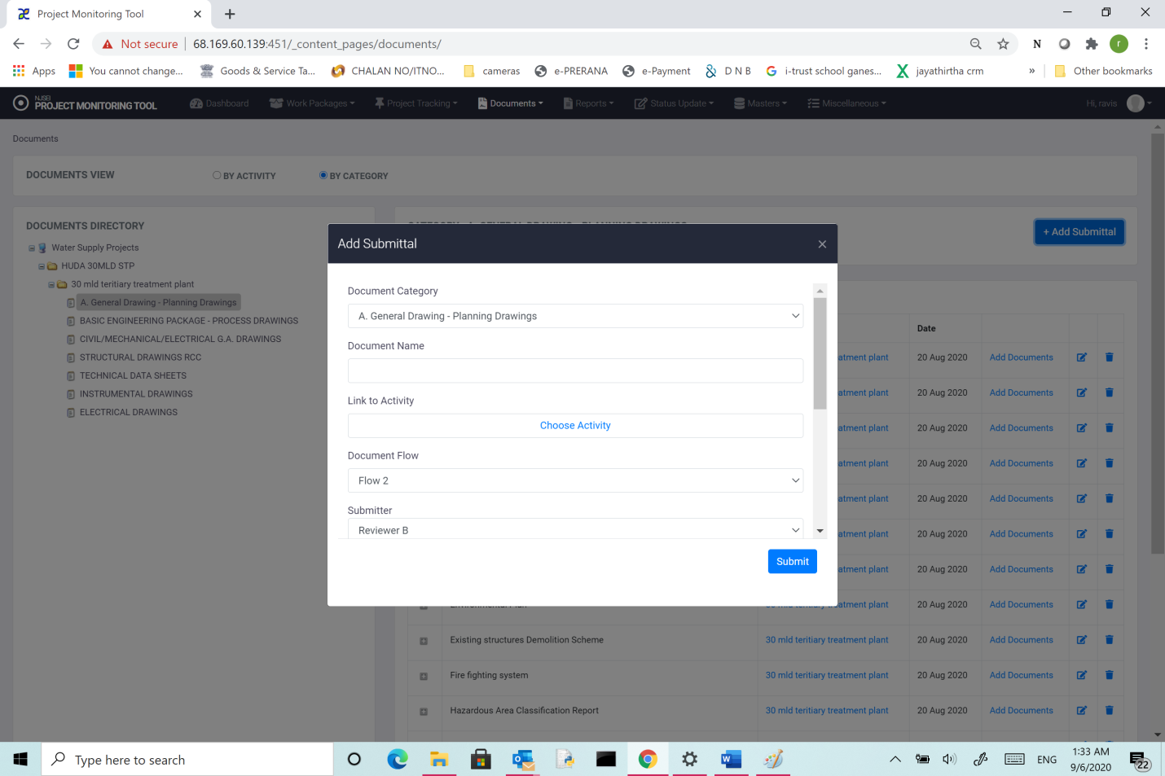

The fields are shown below.

1. Document Name: Name of the submittal.
2. Document category: A drop down list of pre-defined categories. Choose one.
3. Document flow: This defines a process a submittal flows through. This includes
4. Steps and the sequence of steps (Example: Submission, review, approval)
5. Users who are responsible for each step to be completed.
6. Suggested target date.
7. If you have clocked “by activity“,you will see following screen. Click the activity you want to see
8. You will see list of submittals under that category.
9. For each submittal
10. You can see date it was added.
11. A link to add documents to the submittal.
12. Edit properties of the submittal.
13. Delete the submittal

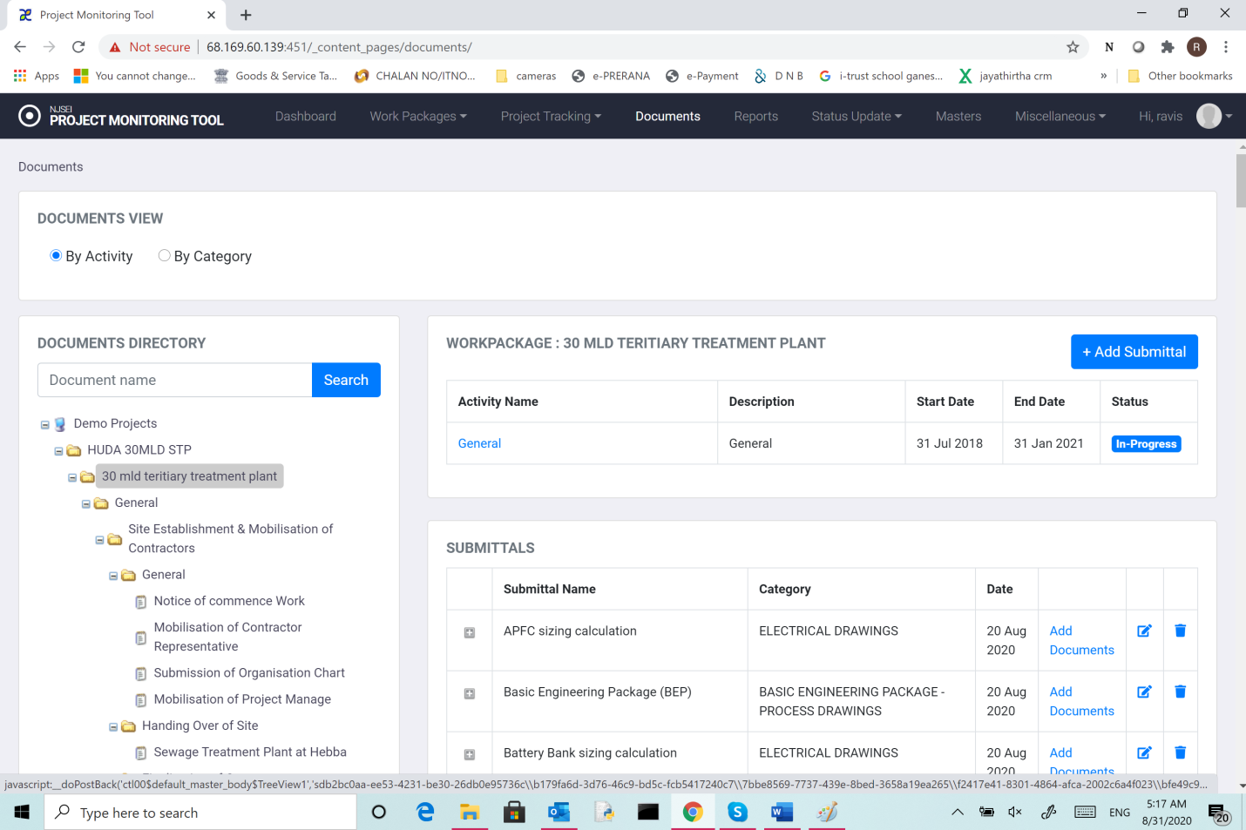

**5.1.3Deleting a submittal:**

1. Click “Documents” in main menu bar.
2. Click “View Documents”.
3. Click “By category”
4. Click the work package for which submittal belongs
5. Click the delete (thrash symbol) in the row which shows submittal.

You will see following screen.

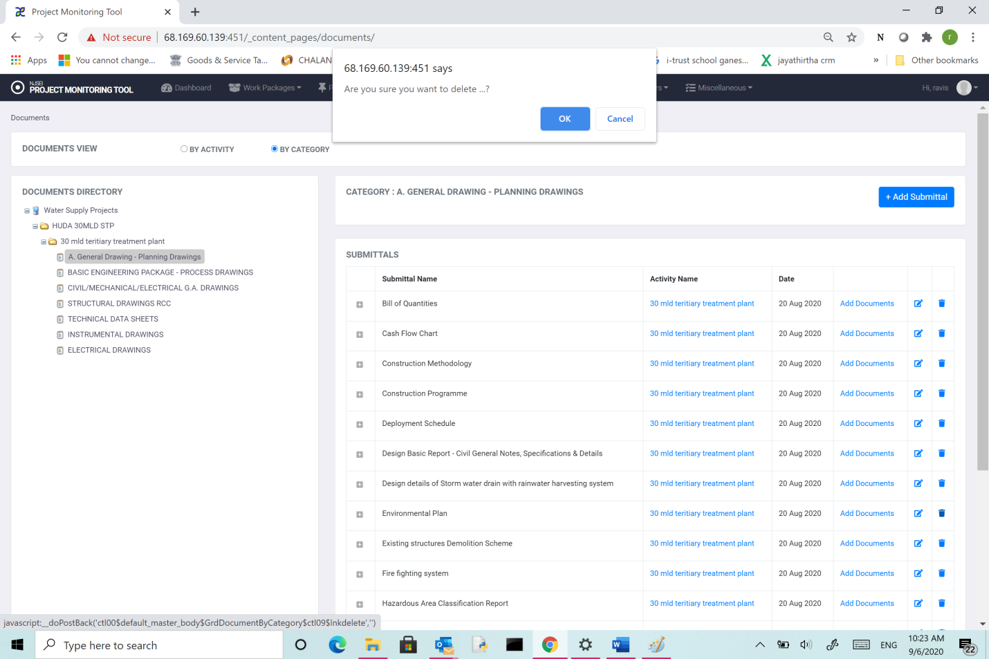

Click “OK”.

The corresponding submittal will be removed from the list.

**5.1.4 Editing a submittal:**

1. Click “Documents” in main menu bar.
2. Click “View Documents”.
3. Click “By category”
4. Click the work package for which submittal belongs
5. Click the Edit (Scribe symbol) in the row which shows submittal.
6. You will see following screen

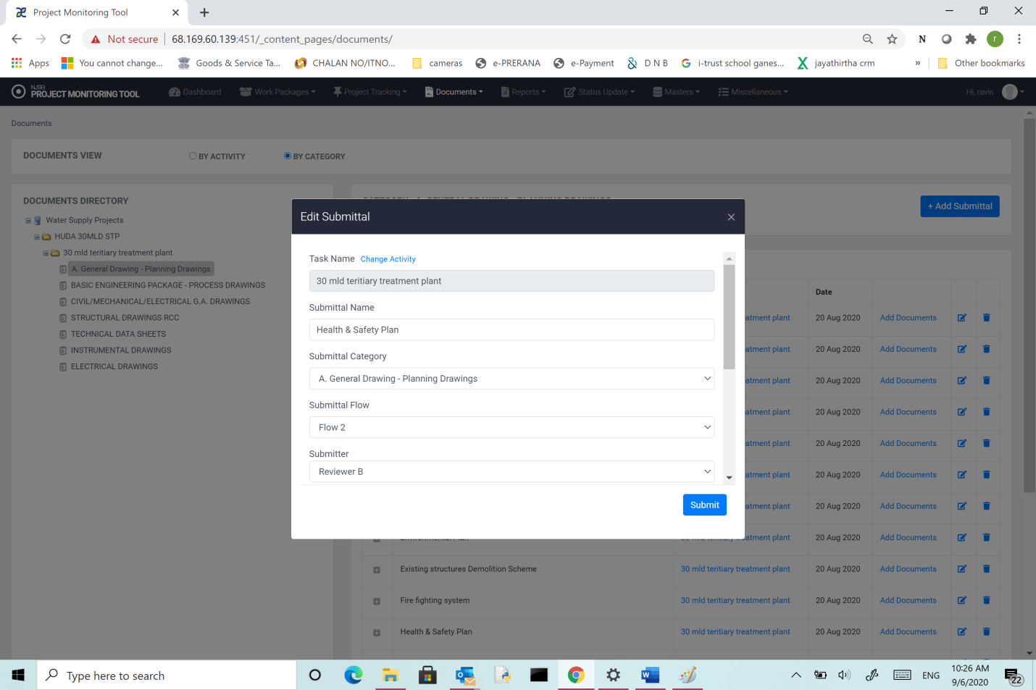

You can change any property of the submittal and click “Submit”. The changed property of the submittal will be updated in the system.

* 1. **Submitting a document (first part of a flow generally):**

1. Click “Documents” in main menu bar.
2. Click “By category”
3. Click the category for which submittal belongs
4. Choose the submittal and click “add documents” and you will see following screen.

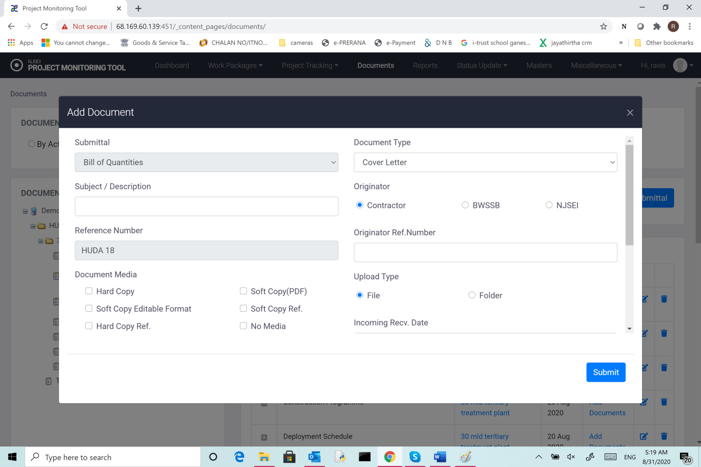

The fields are

1. Subject/Description: Any description for the submittal that would help describe it.
2. Reference number: This is system generated reference number to identify the submission for NJSE documents. For Contractor and BWSSB options, this field is entered based on the letter received.
3. Document media: Select the media on which the document was submitted.
4. File reference number: This is the reference number used in current system where the correspondence is filed.
5. Remarks: Any additional noting while uploading.
6. Document type: Choose if the document is a cover letter or a general document.
7. Originator: Source of the document (Contractor/BWSSB/NJSE)
8. Originator reference number: The reference number in the cover letter received.
9. Incoming receive date: date on which the cover letter and documents were received.
10. Cover letter date: date the cover letter is dated.
11. Choose file (cover letter): file that has scanned copy of cover letter.
12. File or folder: There can be a single document or multiple documents in a folder. Choose appropriate option.
13. Choose file or folder: Browse the local system and select the file or folder to be uploaded.
14. Click “Submit” to submit the document.
    1. **Updating status of a document (part of a flow):**
15. Click “Documents” in main menu bar.
16. Click “by category”
17. Click the category for which submittal belongs
18. On the right panel expand the submittal by clicking on “+” sign.
19. On the document whose status you want to update click on “view history”.
20. You will see following screen.

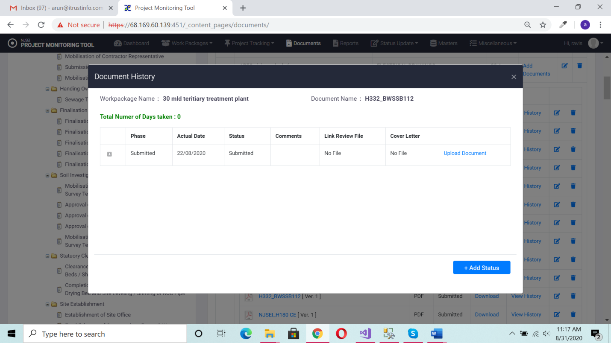

1. Click on “Add status”. You will see following screen.

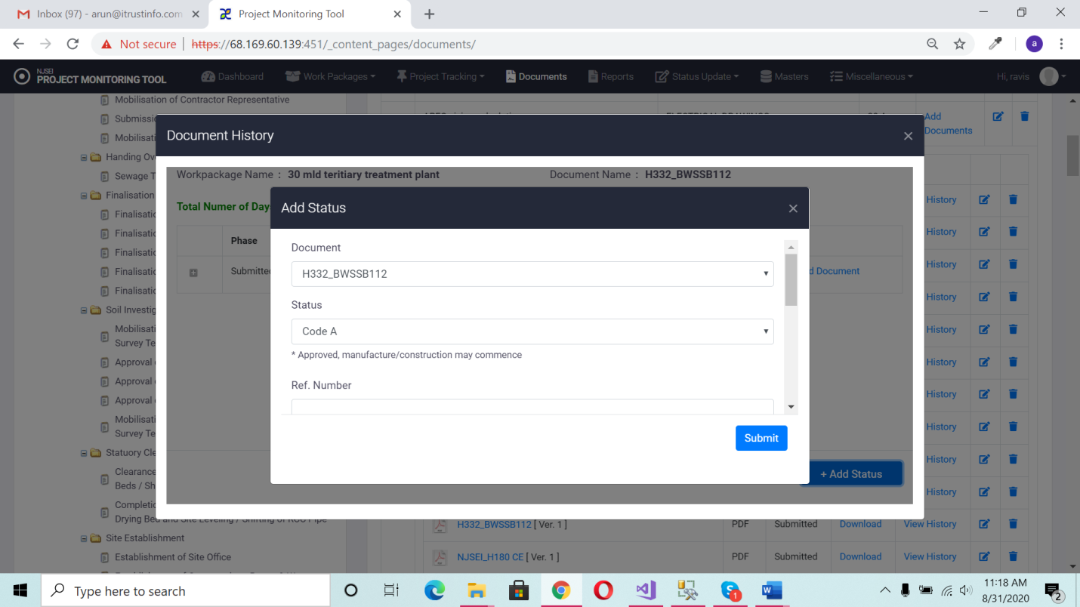

1. The “status” shows a drop down of possible states you can move the documents (based on the flow process) and user.
2. Choose a status.
3. Add a reference number .
4. Enter date of cover letter.
5. Choose actual date.
6. Browse and select scanned copy of cover letter.
7. Browse and select “review file” (the file that contains review feedback, if any).
8. Enter additional comments.
9. Click “submit”.

You will see following screen which shows the document had been updated.

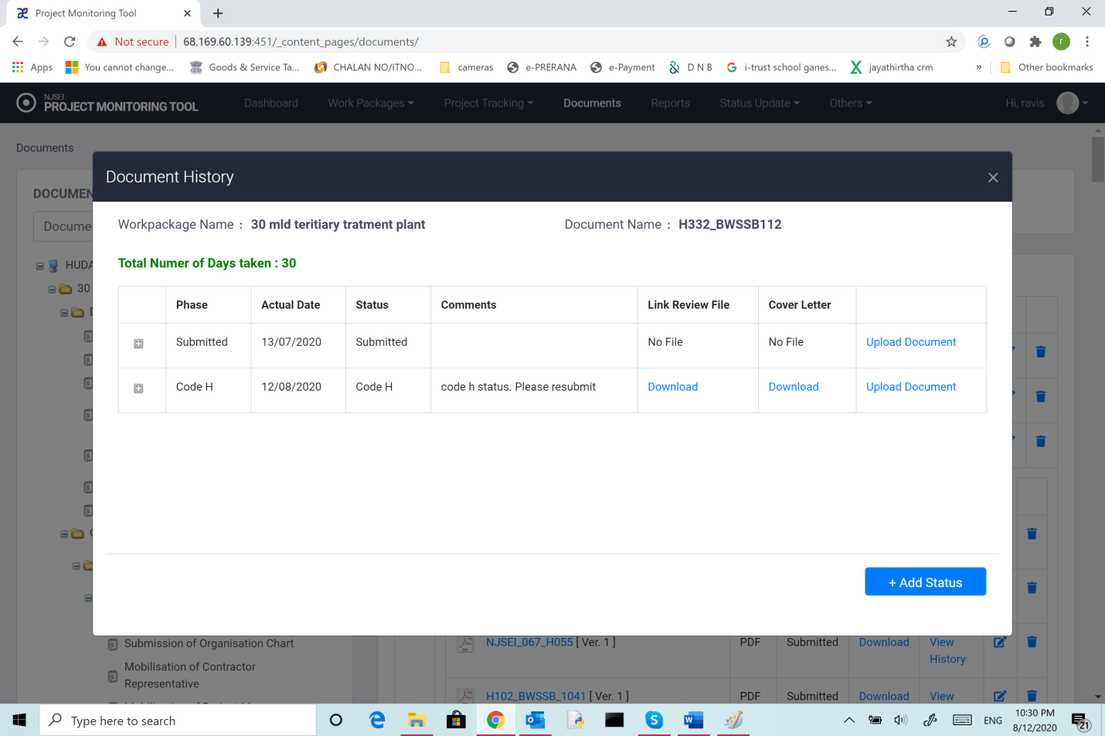

* 1. **View History: (of the documents)**

1. Click “Documents” in main menu bar.
2. Click the category for which submittal belongs
3. On the right panel expand the submittal by clicking on “+” sign.
4. On the document whose status you want to update click on “view history”.
5. You will see following screen.

